3ος Παγκόσμιος πόλεμος για να σωθούν οι ολιγάρχες!

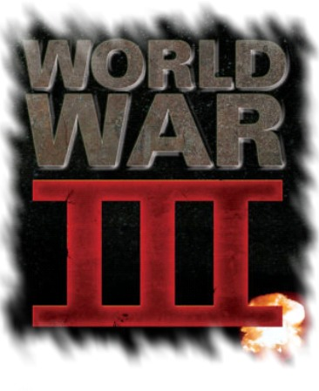
Μετά από Γαλλική είδηση, τα Κινεζικά μέσα ενημέρωσης και άλλα ευρωπαϊκά αργότερα, σε μεγάλη ένταση ανάφεραν και σχολίασαν την τελευταία συνάντηση μεταξύ του πολυεθνικού «think tank» RAND και του Πενταγώνου στις ΗΠΑ.
Ο Οργανισμός Ροκφέλλερ & Φορντ-Κάρνεγκι που βρίσκεται πίσω από τη RAND πρότεινε ότι ένας πόλεμος των ΗΠΑ με μια άλλη μεγάλη παγκόσμια δύναμη θα αναζωογονούσε την οικονομία βοηθώντας την παρούσα Τραπεζική ελίτ να συνεχίσει την άσκηση του ελέγχου της πάνω στην Αμερική.
Οι διευθυντές του Rand που είναι επίσης μπλεγμένοι στη διαβόητη ομάδα Carlyle που διοικείται από πρώην πολιτικούς ζήτησαν τα $5 τρισεκατομμύρια δολάρια του προγράμματος διάσωσης της οικονομίας να χρησιμοποιηθούν για την χρηματοδότηση ενός νέου πολέμου! Η ακριβής χώρα που θα δεχτεί την επίθεση δεν έγινε γνωστή αλλά οι πιθανοί υποψήφιοι είναι η Ρωσία, η Κίνα, το Ιράν και πιθανόν ακόμα και η Ιαπωνία αφού αυτοί κρατάνε το περισσότερο χρέος των ΗΠΑ. Ο αναλυτής της RAND κατέστησε σαφές στο Πεντάγωνο και στους πολιτικούς κυβερνητικούς αξιωματούχους που ήταν παρόντες ότι η επίθεση πρέπει να γίνει σε ένα έθνος μεγάλης επιρροής ξένης ισχύος. Γι' αυτό το λόγο η Βόρεια Κορέα γρήγορα απορρίφθηκε.
πηγές:
WWIII Encouraged by Rand Corporation (4-11-2008)
Chinese news exposes the Rand Corporations plans to start World War III (30-10-2008)

Επίσης:
Rand Corporation Lobbies Pentagon To Start Major War To Save The US Economy
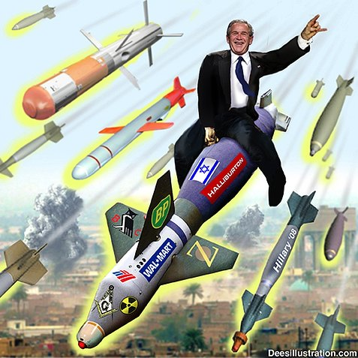
According to reports out of top Chinese mainstream news outlets, the RAND Corporation recently presented a shocking proposal to the Pentagon in which it lobbied for a war to be started with a major foreign power in an attempt to stimulate the American economy and prevent a recession.
A fierce debate has now ensued in China about who that foreign power may be, with China itself as well as Russia and even Japan suspected to be the targets of aggression.
The reports cite French media news sources as having uncovered the proposal, in which RAND suggested that the $700 billion dollars that has been earmarked to bailout Wall Street and failing banks instead be used to finance a new war which would in turn re-invigorate the flagging stock markets.
The RAND Corporation is a notoriously powerful NGO with deep ties to the U.S. military-industrial complex as well as interlocking connections with the Ford, Rockefeller, and Carnegie foundations.
Current directors of RAND include Frank Charles Carlucci III, former Defense Secretary and Deputy Director of the CIA, Ronald L. Olson, Council on Foreign Relations luminary and former Secretary of Labor, and Carl Bildt, top Bilderberg member and former Swedish Prime Minister.
Carlucci was chairman of the Carlyle Group from 1989-2005 and oversaw gargantuan profits the defense contractor made in the aftermath of 9/11 following the invasion of Afghanistan. The Carlyle Group has also received investment money from the Bin Laden family. Read more…
Μεταφρασμένη στα αγγλικά από τα κινεζικά σελίδα:

Rand Corporation United States military to mention the "war to save the market" with great power war
At 9:02 on October 30, 2008 [I来说两句 (1241) ] [Font Size: 大中小]
Source: International online
Rand's "war to save the market theory" ridiculous
雷思海
According to the French media, the U.S. think tank the Rand Corporation has been the Department of Defense agencies submitted an assessment report, the assessment to launch a war to pass the feasibility of the current economic crisis. The report, with 700 billion U.S. dollars to rescue the market effect, it may not be used 700 billion U.S. dollars to launch a war, and the object of the war against Iraq with the past or different parts of Afghanistan may be a big country.
It is undeniable that the war has always been a continuation of politics, and economic and political foundation and ultimate goal. Continued deepening of the U.S. sub-loan crisis and economic recession, has developed to a certain extent, most likely induced by the war, so as to achieve the purpose of the crisis shifted.
From a historical perspective, after World War II, the United States against other countries have launched several wars, particularly in it to become the only superpower after the war even as its main tool to maintain hegemony, such as the wars in Afghanistan and Iraq, etc. . These are the United States was seen as the realization of the "New Roman Empire" ambitious expansion means.
However, on another country, especially the big powers to wage war, by no means a trifling matter, even for a superpower like the United States is no exception. First of all, the current inability of the United States has launched a large-scale war. Recently, the United States by the new Security Center and the United States think-tank "Foreign Policy" magazine, the U.S. military retirees and active duty military officers conducted a public opinion poll showed that nearly 90% of the retired and serving military officers believe that the war in Iraq dragged down by the U.S. military has quietened down considerably, 80 percent of respondents believe that the United States at this time no longer able to launch another large-scale war.
Secondly, the United States has no moral cohesion, it is difficult to find allies in the war. In 1991 the first Gulf War, although it is mainly the U.S. military to fight, but the money is in Japan and Western European allies. War allies to join not only the United States won the moral high point, and obtained the help of a lot of money; but the 2003 war in Iraq, U.S. allies in Western Europe, France, Germany, none joined the opposition, the United States to bear the basic is all the war costs, and the world in the moral condemnation of the media a long time.
This shows that although the United States a very powerful national strength, it can not be changed with the development of human civilization and progress of the war concept. In today's world, the United States to launch a war to divert the financial crisis for the purpose of the war, will work with the same fascist war, the world will surely be cast aside, and to accelerate its decline.
Again, the United States and any of a large country of war, is bound to accelerate the rise of other major countries. The United States is currently facing the worst situation is not limited to domestic and other economies from the threat of the United States is most worried about. French President Nicolas Sarkozy issued a "tear down the U.S. economy, rebuilding the world economy" argument to the U.S. economy overturned hegemony replaced by the European Union; Japan is also actively preparing for the construction sub-element area, replaced the United States in Southeast Asia; Russia are energy and military wings, ready to build a regional rubles; In addition, China has become a recognized leader in the new economic voices in the third world countries one after another.
Under such circumstances, the United States and any of a large country of war, will accelerate the rise of other competitors. The so-called "snipe and the clam grapple fight, the fisherman profits", in World War I and World War II, the United States are waiting for the two warring sides have huge losses when it is added at the end of profit, which can be achieved hegemony in the world today . Old Road, the United States in this, how would not it?
Therefore, the United States think tank of the "war to save the U.S. financial crisis" argument, may seem a threat to other countries, but in essence is a "near-despair" emotional performance. With the financial crisis is a struggle between different interests of any one of the world's major powers war would be a struggle for survival, regardless of Russia, China, India and European countries or the United States itself is concerned, will be involved in more than more fundamental interests of competing for the right to life is the core countries in the interests of any one State can not give up. Therefore, the United States if the adoption of other great powers of war to solve the financial crisis, in the nuclear era, is does not have the interoperability is not feasible.
In the financial turmoil in the world, the countries have challenged the current U.S. dollar hegemony as the main indicator of the irrational international financial system, and U.S. allies are European Union countries raised the idea of returning to the Bretton Woods system. On the 15th next month, the upcoming global financial summit, the United States on the war to rescue the market, rather than the real U.S. strategy options, not as good as said that the United States a bargaining chip to increase the shout out. International Online - World Business News
(Editor:肖尧) [I来说两句 (1241��)]

www.imdleo.gr

